**Journey of Docker**

* A startup based of sanfransisco called dot cloud was working on PAAS products on cloud. For their internal activities they needed to create lxc (Linux containers), so they developed a product called as Docker and made it opensource.
* Later on, dotCloud became Docker Inc as Docker was a huge success.
* Docker has democratised containers.
* Architecture

Generation I:  
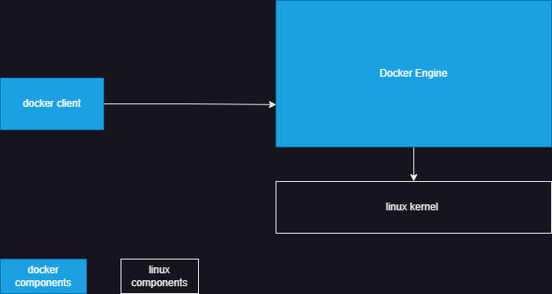

Generation II:  
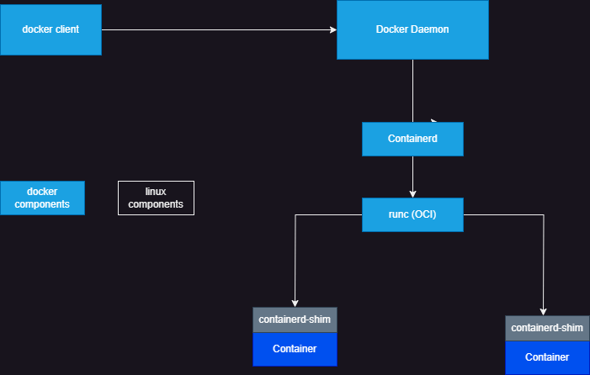

Standards:

* OCI (Open Container Initiative) <https://opencontainers.org/>

The **Open Container Initiative** is an open governance structure for the express purpose of creating open industry standards around container formats and runtimes.

* Containerd <https://containerd.io/>

An industry-standard container runtime with an emphasis on simplicity, robustness and portability

**Docker Archiecture**

* Docker client is a simple command line tool
* client will speak with docker daemon which has api’s to connect
* docker daemon forwards the request to containerd which knows how to pull images, maintain network etc… (high level runtime)
* to create container containerd calls docker low level runtime (libcontainer)

**Install Docker on a Linux Machine**

sudo apt-get update

sudo apt-get install ca-certificates curl gnupg -y

sudo install -m 0755 -d /etc/apt/keyrings

curl -fsSL https://download.docker.com/linux/ubuntu/gpg | sudo gpg --dearmor -o /etc/apt/keyrings/docker.gpg

sudo chmod a+r /etc/apt/keyrings/docker.gpg

echo \

"deb [arch="$(dpkg --print-architecture)" signed-by=/etc/apt/keyrings/docker.gpg] https://download.docker.com/linux/ubuntu \

"$(. /etc/os-release && echo "$VERSION_CODENAME")" stable" | \

sudo tee /etc/apt/sources.list.d/docker.list > /dev/null

sudo apt-get update

sudo apt-get install docker-ce docker-ce-cli containerd.io docker-buildx-plugin docker-compose-plugin -y

Add your current user to docker group so that docker client can access docker daemon without sudo permissions

sudo usermod -aG docker Dell

#exit and relogin

docker version

